Networking

NAT -
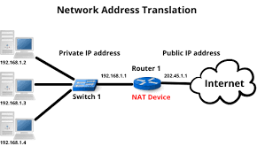

A NAT gateway is a Network Address Translation (NAT) service. You can use a NAT gateway so that instances in a private subnet can connect to services outside your VPC but external services cannot initiate a connection with those instances.

DMZ -
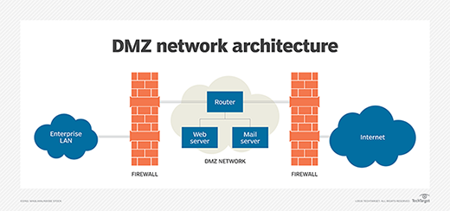

When WAN wants to communicate with LAN directly its not possible, then we use
DMZ. DMZ is a security where if we want to connect to LAN firstly it goes to router
then sends to DMZ then it reaches to LAN this is how we connect WAN to LAN by DMZ

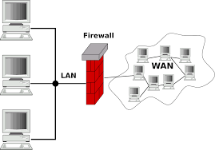
Firewall -

A firewall is a security system designed to prevent unauthorized access into or out of a computer network. Firewalls are often used to make sure internet users without access are not able to interface with private networks

Port forwarding -

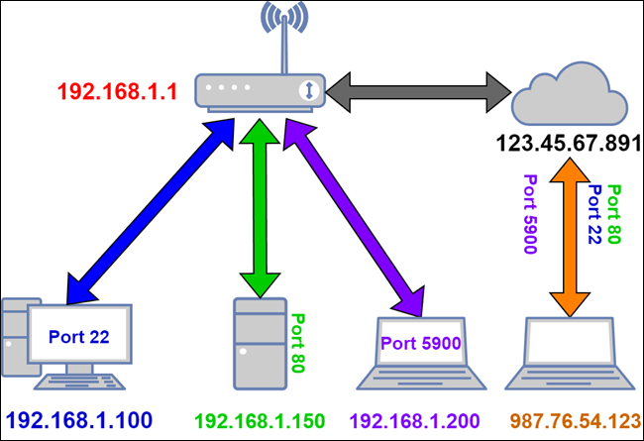

Port Forwarding (or port mapping) allows external traffic from the internet to connect to a device, like a computer, on a private network.

IP (Internet protocol) -
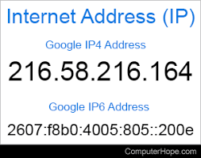

An IP address is a string of numbers separated by periods. IP addresses are expressed as a set of four numbers. An Internet Protocol address (IP address) is a numerical label such as 192.0.2.1 that is connected to a computer network that uses the Internet protocol for communication.An IP address serves two main functions: network interface identification and location addressing

 | TCP | UDP
Full form | It stands for Transmission Control Protocol. | It stands for User Datagram Protocol.
Type of connection | It is a connection-oriented protocol, which means that the connection needs to be established before the data is transmitted over the network. | It is a connectionless protocol, which means that it sends the data without checking whether the system is ready to receive or not.
Reliable | TCP is a reliable protocol as it provides assurance for the delivery of data packets. | UDP is an unreliable protocol as it does not take the guarantee for the delivery of packets.
Speed | TCP is slower than UDP as it performs error checking, flow control, and provides assurance for the delivery of | UDP is faster than TCP as it does not guarantee the delivery of data packets.
Header size | The size of TCP is 20 bytes. | The size of the UDP is 8 bytes.
Acknowledgment | TCP uses the three-way-handshake concept. In this concept, if the sender receives the ACK, then the sender will send the data. TCP also has the ability to resend the lost data. | UDP does not wait for any acknowledgment; it just sends the data.

HTTP -

HTTP stands for HyperText Transfer Protocol. It is a protocol used to access the data on the World Wide Web (www). The HTTP protocol can be used to transfer the data in the form of plain text, hypertext, audio, video, and so on. This protocol is known as Hyper Text Transfer Protocol because of its efficiency that allows us to use in a hypertext environment where there are rapid jumps from one document to another document.

SMTP -

SMTP stands for Simple Mail Transfer Protocol. SMTP is a set of communication guidelines that allow software to transmit an electronic mail over the internet is called Simple Mail Transfer Protocol. It is a program used for sending messages to other computer users based on e-mail addresses. It provides a mail exchange between users on the same or different computers. It can send a single message to one or more recipients. Sending message can include text, voice, video or graphics. It can also send the messages on networks outside the internet. The main purpose of SMTP is used to set up communication rules between servers. The servers have a way of identifying themselves and announcing what kind of communication they are trying to perform. They also have a way of handling the errors such as incorrect email address.

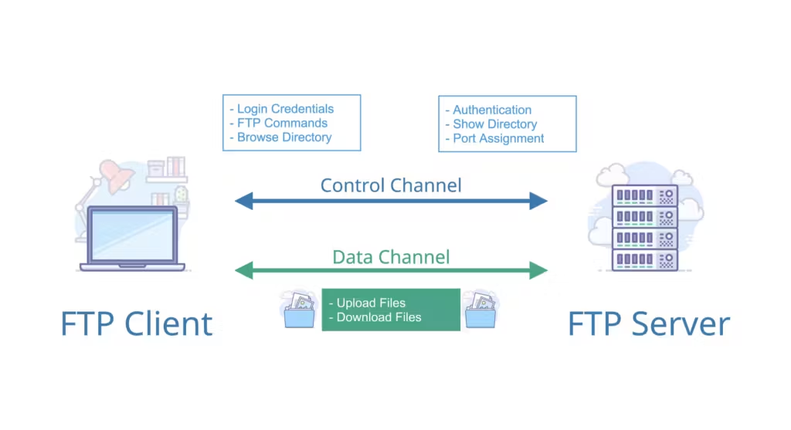
FTP -

FTP stands for File transfer protocol. FTP is a standard internet protocol provided by TCP/IP used for transmitting the files from one host to another. It is mainly used for transferring the web page files from their creator to the computer that acts as a server for other computers on the internet. It is also used for downloading the files to computer from other servers.

Proxy / Forward proxy -

A forward proxy, often called a proxy, proxy server, or web proxy, is a server that sits in front of a group of client machines. When those computers make requests to sites and services on the Internet, the proxy server intercepts those requests and then communicates with web servers on behalf of those clients, like a middleman.

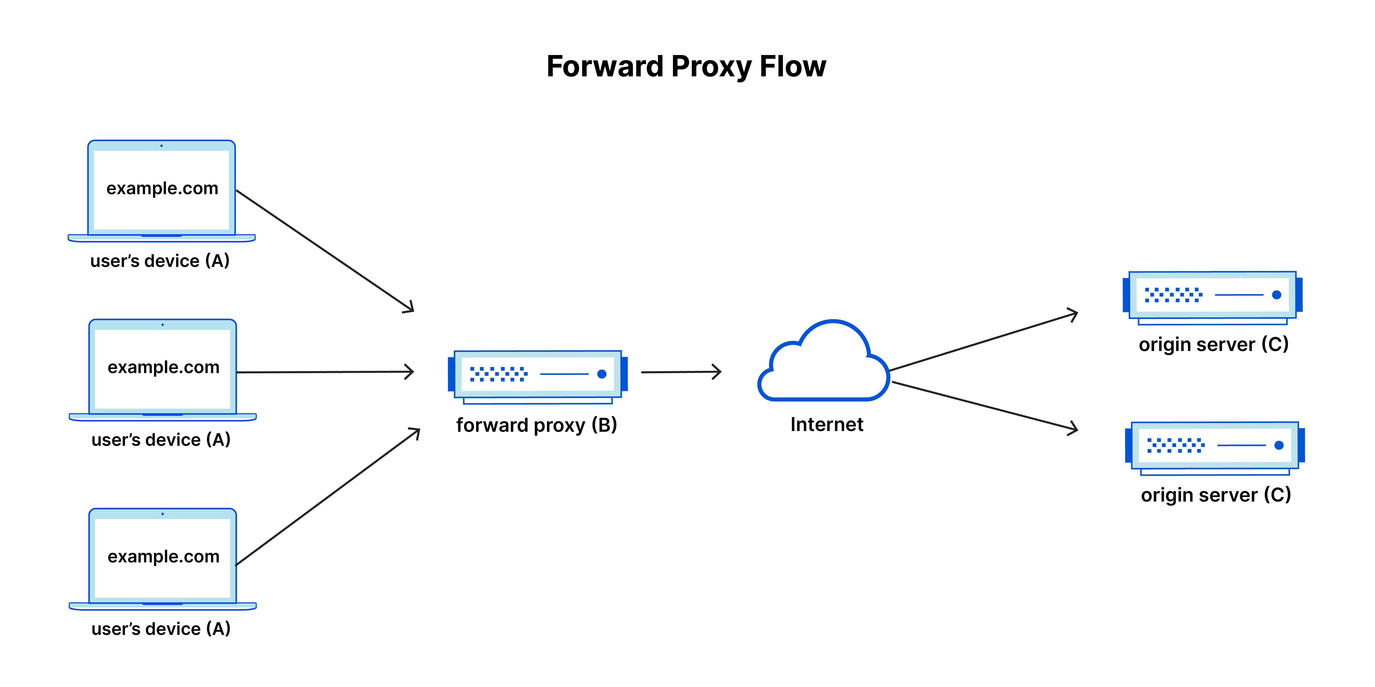

Reverse Proxy -

A reverse proxy is a server that sits in front of one or more web servers, intercepting requests from clients. This is different from a forward proxy, where the proxy sits in front of the clients. With a reverse proxy, when clients send requests to the origin server of a website, those requests are intercepted at the network edge by the reverse proxy server. The reverse proxy server will then send requests to and receive responses from the origin serve
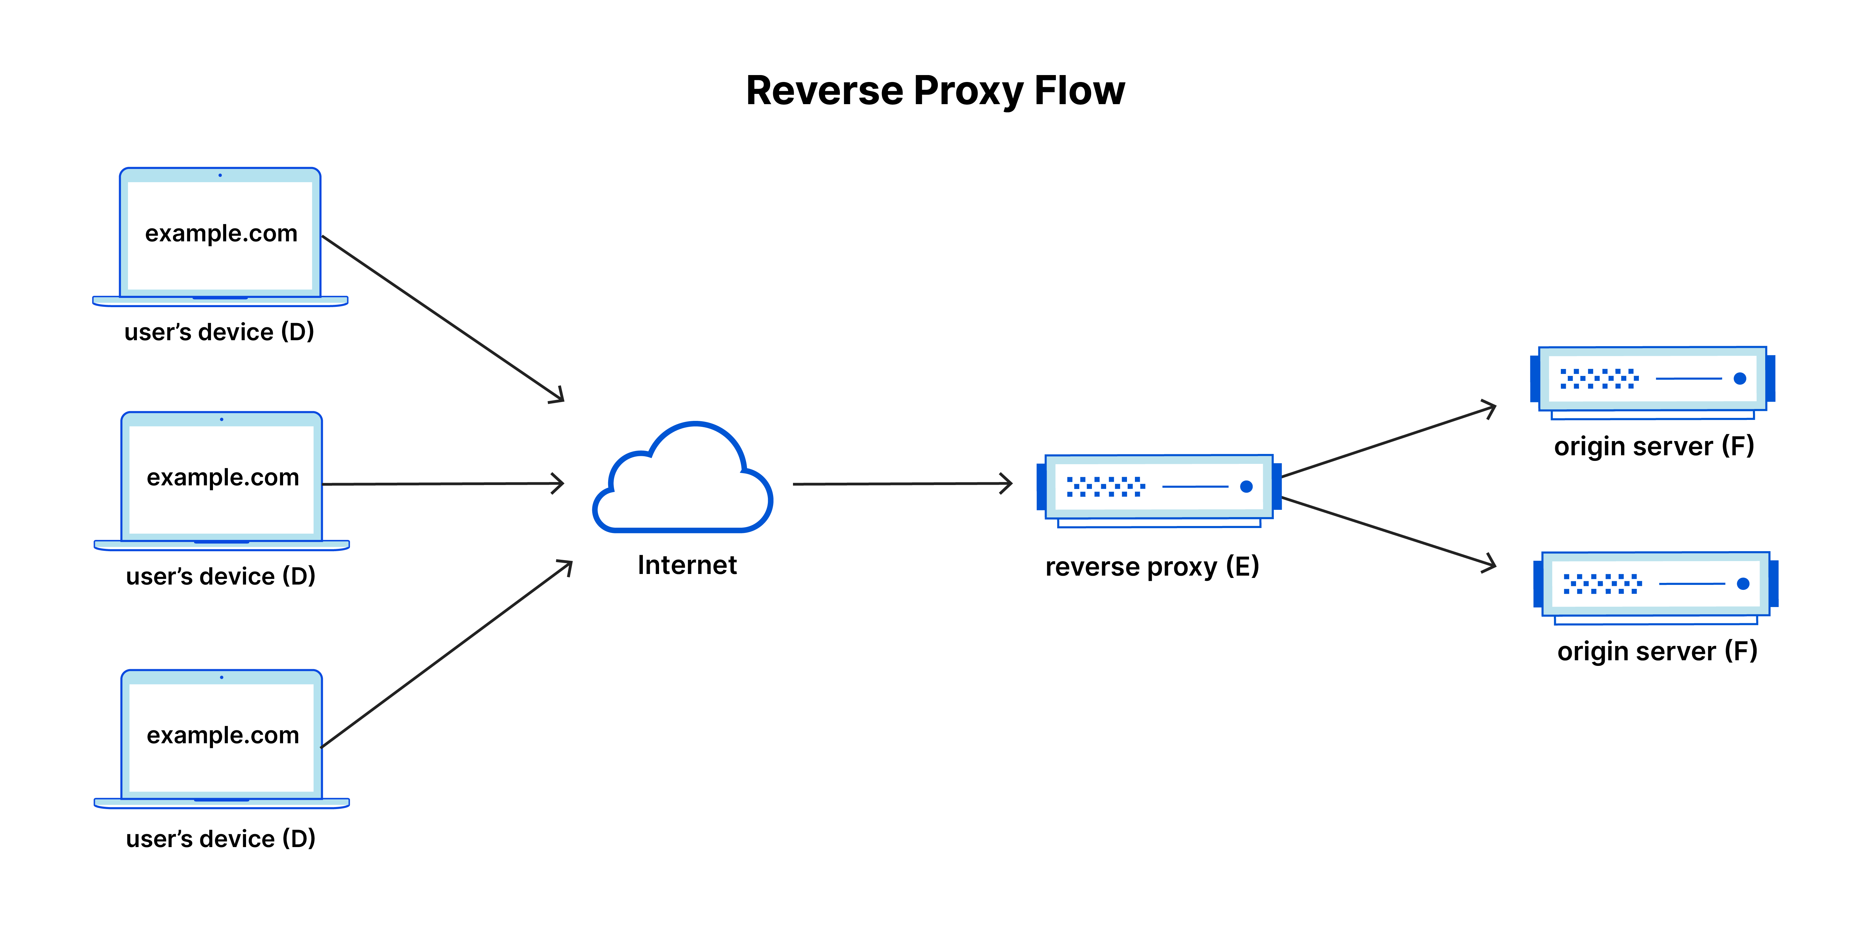

Setting up a proxy server -

We Installed Squid proxy server in our local system,
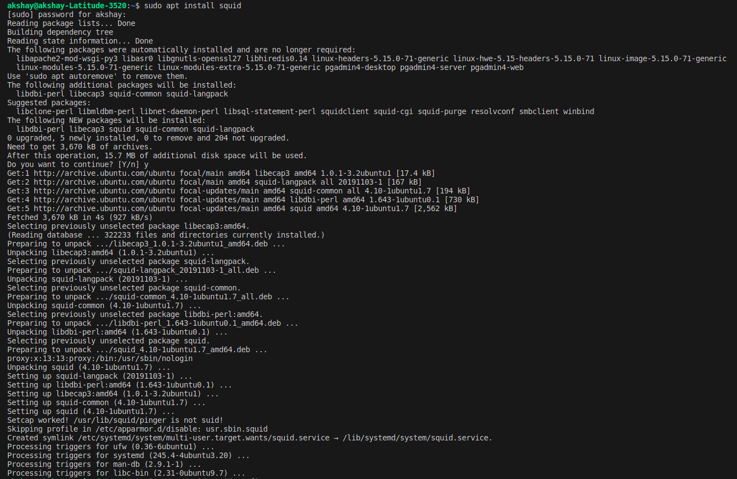

1. Sudo apt install squid
2. sudo vim /etc/squid/squid.conf
change some of the permission and add some rules
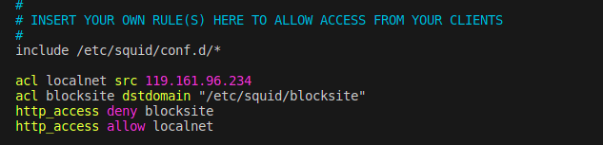
add these lines in the file, and change deny to allow

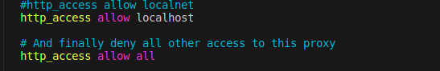

3. sudo vim /etc/squid/blocksite
Enter the websites name which you want to block
eg: www.facebook.com, www.flipkart.com
4. sudo systemctl restart squid
5. Now, go to settings and change proxy settings to
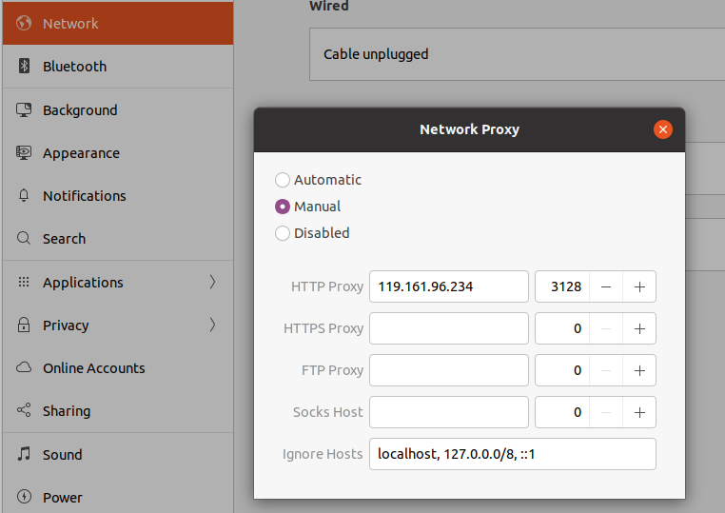

after these changes
6. Go to browser and search website you should be getting an error while opening the site

